**Exercise 1:**

#include <stdio.h>

#include <stdlib.h>

int checkISBN(int n){

int re = 0;

int m[11], c[11];

int k[9]={10,9,8,7,6,5,4,3,2};

int i;

int sumn;

if (n > 1000000){

for (i=10; i>0; i--){

m[i] = n%10;

n = n/10;

}

sumn=0;

sumn = sumn+m[10];

for (i=1; i<10; i++){

c[i]=k[i-1]*m[i];

sumn = sumn+c[i];

}

if (sumn%11 ==0) re=1;

}

return re;

}

int main() {

int n;

do {

printf("Enter number ( 10 digits) - or O to stop: ");

scanf("%d", &n);

if (checkISBN(n) == 1) printf("\t%d is a valid ISBN\n", n);

else printf("\t%d is not a valid ISBN\n", n);

} while (n != 0);

printf("Have a nice day!");

return 0;

}

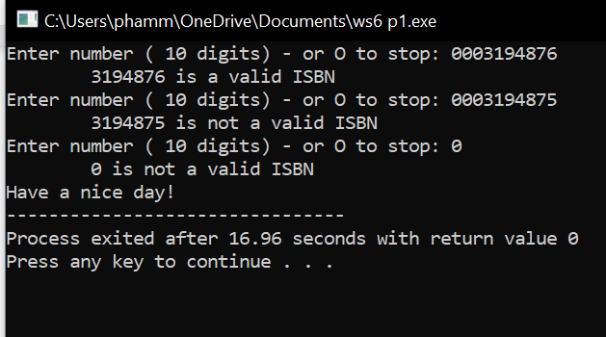

**Exercise 2:**

#include <stdio.h>

#include <stdlib.h>

const int MAX = 100;

double checkNumber(int *n, char buffer);

void addArray(int array[], int *size);

void searchArray(int array[], int size);

void printArray(int array[], int size);

void arrayAscend(int array[], int size);

void arrayDescend(int array[], int size);

void rangeOfArray(int array[], int size);

void showOp();

int main()

{

int array[MAX];

int size = 0;

int choice, n, buffer;

do{

showOp();

do{

choice = checkNumber(&n, buffer);

if(choice<1 || choice>9){

printf("\nVui long chon tu 1-9: ");

}

}while(choice <1 || choice > 9);

switch(choice){

case 1:{

addArray(array, &size);

printf("\n");

break;

}

case 2:{

searchArray(array, size);

printf("\n");

break;

}

case 3:{

printArray(array,size);

printf("\n");

break;

}

case 4:{

rangeOfArray(array, size);

printf("\n");

break;

}

case 5:{

arrayAscend(array, size);

printf("\n");

break;

}

}

}while(choice != 6);

printf(" OK bye hehe");

}

void showOp(void){

printf(" MENU ");

printf("\n1- Add a value.");

printf("\n2- Search a value");

printf("\n3- Print out the array");

printf("\n4- Print out values in a range");

printf("\n5- Print out the array in ascending order");

printf("\n6- Quit");

printf("\n------------------------");

printf("\nSelect an operation: ");

}

double checkNumber(int *n, char buffer){

do{

scanf("%d", n);

scanf("%c", &buffer);

fflush(stdin);

if(buffer != 10){

printf("\nNumber ");

printf("\nNhap lai: ");

}else{

return *n;

}

}while(buffer != 7);

}

void addArray(int array[], int *size){

printf("\nSize: ");

scanf("%d", size);

for(int i = 0; i<= *size - 1; i++){

printf("\nArray[%d]: ", i);

scanf("%d", &array[i]);

}

printf("\n------------");

printf("\nOk");

}

void searchArray(int array[], int size){

if(size == 0){

printf("\nError");

return;

}

int key;

printf("\nKey: ");

scanf("%d", &key);

int count = 0;

printf("\nLocation %d: ", key);

for(int i = 0; i<= size -1; i++){

if(array[i]== key){

printf("%5d", i);

count++;

}

}

if(count == 0){

printf("\nThere are no %d in array", key);

}

}

void printArray(int array[], int size){

if(size == 0){

printf("\nError");

return;

}

printf("\n");

for(int i = 0; i <= size -1; i++){

printf("%5d", array[i]);

}

}

void rangeOfArray(int array[], int size){

if(size == 0){

printf("\nError");

return;

}

int min, max;

printf("\nMin: ");

scanf("%d", &min);

printf("\nMax: ");

scanf("%d", &max);

printf("\nValue min and max: ");

for(int i = 0; i <= size -1; i++){

if(array[i] >= min && array[i] <= max){

printf("%5d", array[i]);

}

}

}

void arrayAscend(int array[], int size){

if(size == 0){

printf("\nError");

return;

}

int minIndex;

int i, j;

for(i = 0; i<=size -1; i++){

for(j=i+1; j<= size-1; j++){

if(array[i]>array[j]){

int t = array[i];

array[i] = array[j];

array[j] = t;

}

}

}

printArray(array, size);

}

void arrayDescend(int array[], int size){

if(size == 0){

printf("\nError");

return;

}

int i, j;

for(i = 0; i<=size -1; i++){

for(j=size - 1; j>i; j--){

if(array[j]>array[j-1]){

int t = array[j];

array[j] = array[j-1];

array[j-1] = t;

}

}

}

printArray(array, size);

}

